**Hussein Abdikarim Assignment/ HW-1**

**PA REPORT- 1**

**Problem Statement and Code Design**

**This assignment deals with 2 problems.First one requires the given elements to be returned in spiral form. To do this, I implemented a linkList and a 2D array while the second question required Implementing a Java solution that calculates the range of bitcoin values for the current day, given the series of n daily values of this coin. My code includes several sub-parts to make it modular. These sub modules are basically defined using a structure chart below.**

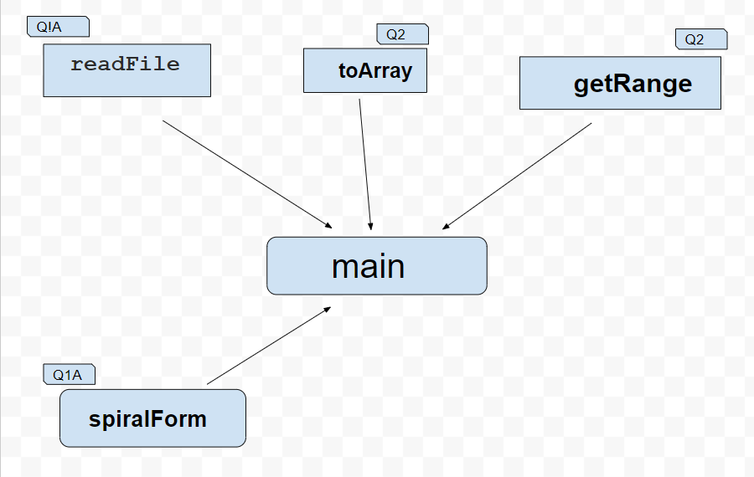

**Implementation, Functionality**

**To explain the functionality of this program, we have to dive into the methods mentioned above.**

**How does it work?**

**First of all, all these classes require a read input like a txt file. After that, each class tackles the problems related to its question. For example, in Q1A returning a spiral form requires a matrix which is in txt format. To do this, we read the txt file into a String then add it to a list which later changes to a 2D array with the help of a linkList of a linkList.**

**In the second problem, we read a txt into a file then add it to a Stack. After that, we use the toArray method that changes from stack to array and do the necessary calculations to acquire a solution.**

**To explain further more, the above mentioned methods will be defined as follows.**

1. **readFile: Takes a file as an input that reads it to a list and from there, adds it to a linkList of a linkList which later is converted into a 2D array that is used in the spiralForm.**
2. **spiralForm: Takes a 2D matrix as an input and creates 4 boundaries to iterate through the 2D array in a spiral format.**
3. **toArray: It takes the Stack that was read from the txt file and converts it to an array to ease the calculations.**
4. **getRange: It compares the values in the array and iterates through the whole array and returns the desired numbers which it stores in a Stack and prints it.**

**FINAL ASSESSMENTS**

1. **I had trouble reading the txt files because it was a new concept to me. I also did not know that compressed files makes java unable to find the right path of the file. In the end, I was able to find the right implementation with the help of research and tying the problems.**
2. **Another major problem for me was the vpl.Sometimes my code worked in eclipse but didn’t work in the Vpl. I had to redesign my code based on the Vpl.**
3. **In the end, I learned a lot from this report like reading a txt file, implementing my own Stacks and Links which needed to be flexible with my other codes. This assignment was also a refresher for me as it made me go back to String and other known classes in java.**